**Quiz for Java Programming** (Tutor: cyd@bupt.edu.cn)

Unit04-GUI Programming – JavaFX Basics

1. A JavaFX program should explicitly override Application. start method.
2. In JavaFX, an Stage is the basic class of a program; a Scene is like a window; a

Pane is like a panel for putting components.

1. Write a javafx program which shows one rectangle and a button with text "Hello".

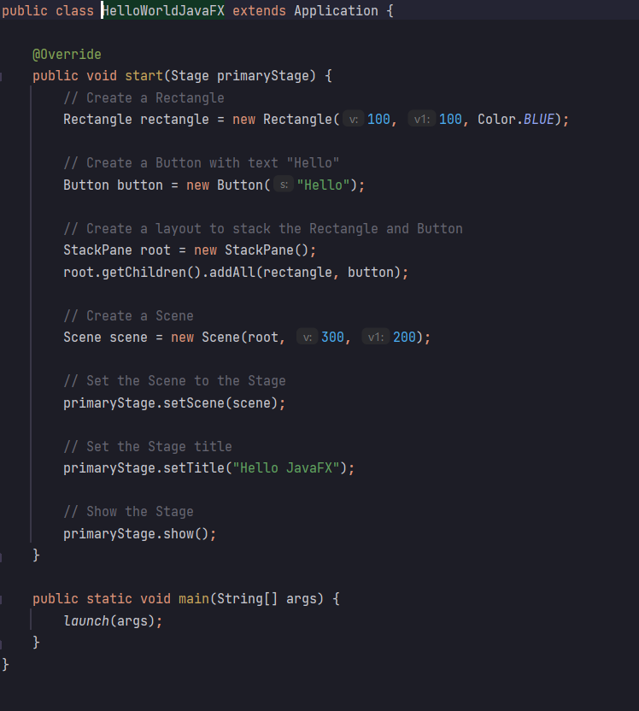

1. Based on quiz3, using binding properties to make the "Hello" button stay in the center when the window is enlarged or shrunk.

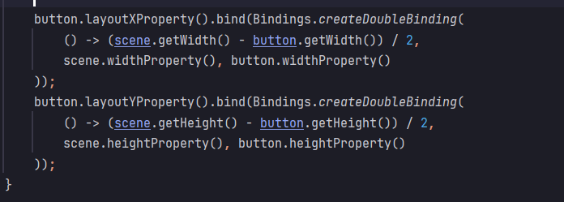

1. Based on quiz4, using Color and Font class to change the properties of the "Hello" button.

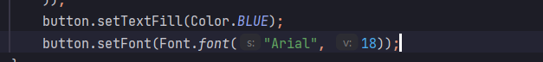

1. Using proper Pane to draw the following picture. You can omit the table border.

|  |  |  |  |
| --- | --- | --- | --- |
|  |  |  |  |
|  |  |  |  |
|  |  |  |  |

|  |  |  |  |  |  |
| --- | --- | --- | --- | --- | --- |
| 56 个民族图标顺序排列 | | | | | |
|  | 乾 | 坤 | 震 | 巽 |  |
| 文本块：唐诗《咏 | （☰） | （☷） | （☳） | （☴） |
| 鹅》 | 坎 | 离 | 艮 | 兑 |
|  | （☵） | （☲） | （☶） | （☱） |
|  | 按钮 1 |  |  | 按钮 2 |  |

All images can be obtained at: <https://gitee.com/bupt-se/jpl-images>

|  |  |  |
| --- | --- | --- |
|  |  |  |
|  |  |  |

